路由器RIP-1配置

实验目的
  - 掌握动态路由的配置方法
  - 理解RIP协议的工作过程

应用环境
  - 在路由器较多的环境里，手工配置静态路由给管理员带来大的工作负担
  - 在不太稳定的网络环境里，手工修改表不现实

实验设备
  - DCR-1702 三台
  - CR-V35FC 一条
  - CR-V35MT 一条

实验拓扑
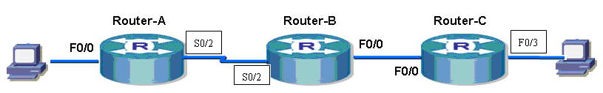
PC1
PC2

实验配置要求
Router-A |  | Router-B |  | Router-C |  | PC
S0/2(DCE) | 192.168.1.1 | S0/2(DTE) | 192.168.1.2 | F0/0 | 192.168.2.2 | PC1 | 192.168.0.2
F0/0 | 192.168.0.1 | F0/0 | 192.168.2.1 | F0/3 | 192.168.3.1 | PC2 | 192.168.3.2

实验步骤
第一步：参照实验7，按照上表配置所有接口的IP地址，保证所有接口全部是up状态，测试连通性。注意：如果用Serial端口（s0/2），必须给端口封装PPP协议，并且DCE设备要配置时钟频率。

第二步：查看ROUTER-A的路由表
Router-A#show ip route
Codes: C - connected, S - static, R - RIP, B - BGP, BC - BGP connected
D - DEIGRP, DEX - external DEIGRP, O - OSPF, OIA - OSPF inter area
ON1 - OSPF NSSA external type 1, ON2 - OSPF NSSA external type 2
OE1 - OSPF external type 1, OE2 - OSPF external type 2
DHCP - DHCP type

VRF ID: 0

第三步：查看ROUTER-B的路由表
Router-B#show ip route
Codes: C - connected, S - static, R - RIP, B - BGP, BC - BGP connected
D - DEIGRP, DEX - external DEIGRP, O - OSPF, OIA - OSPF inter area
ON1 - OSPF NSSA external type 1, ON2 - OSPF NSSA external type 2
OE1 - OSPF external type 1, OE2 - OSPF external type 2
DHCP - DHCP type

VRF ID: 0

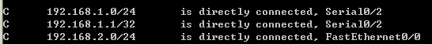

第四步：查看ROUTER-C的路由表
Router-C#show ip route
Codes: C - connected, S - static, R - RIP, B - BGP, BC - BGP connected
D - DEIGRP, DEX - external DEIGRP, O - OSPF, OIA - OSPF inter area
ON1 - OSPF NSSA external type 1, ON2 - OSPF NSSA external type 2
OE1 - OSPF external type 1, OE2 - OSPF external type 2
DHCP - DHCP type

VRF ID: 0

第五步：在ROUTER-A上PING 路由器C
Router-A#ping 192.168.2.2
PING 192.168.2.2 (192.168.2.2): 56 data bytes
.....
--- 192.168.2.2 ping statistics ---
5 packets transmitted, 0 packets received, 100% packet loss ！不通

第六步：在路由器A上配置RIP协议并查看路由表
Router-A_config#router rip ！启动RIP协议
Router-A_config_rip#network 192.168.0.0 ！宣告网段
Router-A_config_rip#network 192.168.1.0
Router-A_config_rip#^Z
Router-A#sh ip route
Codes: C - connected, S - static, R - RIP, B - BGP, BC - BGP connected
D - DEIGRP, DEX - external DEIGRP, O - OSPF, OIA - OSPF inter area
ON1 - OSPF NSSA external type 1, ON2 - OSPF NSSA external type 2
OE1 - OSPF external type 1, OE2 - OSPF external type 2
DHCP - DHCP type

VRF ID: 0

注意：并没有出现RIP学习到的路由

第七步：在路由器B上配置RIP协议并查看路由表
Router-B_config#router rip
Router-B_config_rip#network 192.168.1.0
Router-B_config_rip#network 192.168.2.0
Router-B_config_rip#^Z
Router-B#2004-1-1 00:15:58 Configured from console 0 by DEFAULT
Router-B#show ip route
Codes: C - connected, S - static, R - RIP, B - BGP, BC - BGP connected
D - DEIGRP, DEX - external DEIGRP, O - OSPF, OIA - OSPF inter area
ON1 - OSPF NSSA external type 1, ON2 - OSPF NSSA external type 2
OE1 - OSPF external type 1, OE2 - OSPF external type 2
DHCP - DHCP type

VRF ID: 0
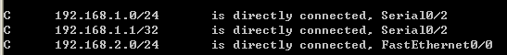

第八步：在路由器C上配置RIP协议并查看路由表（没有黑色背景的为Cisco模拟器结果）
Router-C_config#router rip
Router-C_config_rip#network 192.168.2.0
Router-C_config_rip#network 192.168.3.0
Router-C_config_rip#^Z
Router-C#show ip route
Codes: C - connected, S - static, R - RIP, B - BGP
D - DEIGRP, DEX - external DEIGRP, O - OSPF, OIA - OSPF inter area
ON1 - OSPF NSSA external type 1, ON2 - OSPF NSSA external type 2
OE1 - OSPF external type 1, OE2 - OSPF external type 2

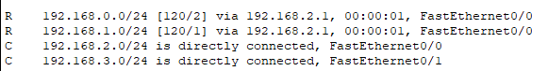

第九步：再次查看A和B的路由表
Router-B#show ip route
Codes: C - connected, S - static, R - RIP, B - BGP, BC - BGP connected
D - DEIGRP, DEX - external DEIGRP, O - OSPF, OIA - OSPF inter area
ON1 - OSPF NSSA external type 1, ON2 - OSPF NSSA external type 2
OE1 - OSPF external type 1, OE2 - OSPF external type 2
DHCP - DHCP type

VRF ID: 0

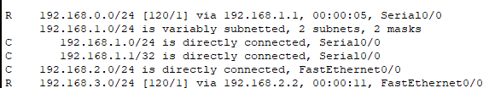
Router-A#show ip route
Codes: C - connected, S - static, R - RIP, B - BGP, BC - BGP connected
D - DEIGRP, DEX - external DEIGRP, O - OSPF, OIA - OSPF inter area
ON1 - OSPF NSSA external type 1, ON2 - OSPF NSSA external type 2
OE1 - OSPF external type 1, OE2 - OSPF external type 2
DHCP - DHCP type

VRF ID: 0

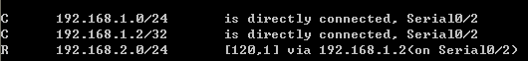
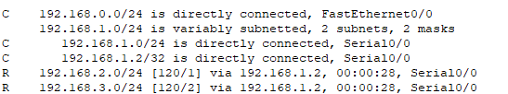
！注意到所有网段都学习到了路由

第十步：用ping命令验证（PC1 ping PC2）
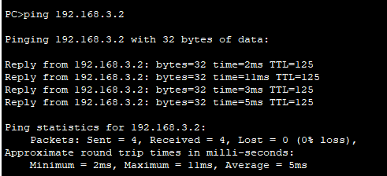
第十一步：相关的查看命令
Router-A#show ip rip ！显示RIP状态
RIP protocol: Enabled
Global version: default( Decided on the interface version control )
Update: 30, Expire: 180, Holddown: 120
Input-queue: 50
Validate-update-source enable
No neighbor

Router-A#sh ip rip protocol ！显示协议细节
RIP is Active
Sending updates every 30 seconds, next due in 30 seconds ！注意定时器的值
Invalid after 180 seconds, holddown 120
update filter list for all interfaces is:
update offset list for all interfaces is:
Redistributing:
Default version control: send version 1, receive version 1 2
Interface Send Recv
FastEthernet0/0 1 1 2
Serial1/1 1 1 2
Automatic network summarization is in effect
Routing for Networks:
192.168.1.0/24
192.168.0.0/16
Distance: 120 (default is 120) ！注意默认的管理距离
Maximum route count: 1024, Route count:6

Router-A#show ip rip database ! 显示RIP数据库

Router-A#sh ip route rip ！仅显示RIP学习到的路由

注意事项和排错
  - 只能宣告直连的网段
  - 宣告时不附加掩码
  - 分配地址时最好是连续的子网，以免RIP汇聚出现错误

配置序列
Router-B#show running-config
Building configuration...

Current configuration:
!
!version 1.3.2E
service timestamps log date
service timestamps debug date
no service password-encryption
!
hostname Router-B
!
!
!
!
!
!
!
interface FastEthernet0/0
ip address 192.168.2.1 255.255.255.0
no ip directed-broadcast
!
interface Serial1/0
ip address 192.168.1.2 255.255.255.0
no ip directed-broadcast
!
interface Async0/0
no ip address
no ip directed-broadcast
!
!
router rip
network 192.168.2.0
network 192.168.1.0

!
!
!

思考
  - 为什么B没有配置RIP协议时，A没有出现RIP路由？
  - 如果不是连续的子网，会出现什么结果？
  - RIP的广播周期是多少？

课后练习
将地址改为10.0.0.0/24这个网段重复以上实验

相关命令详解

router rip
使用router rip 全局命令来配置RIP路由进程，no router rip 则关闭RIP路由进程。
router rip
no router rip
参数
无
缺省
系统缺省不运行RIP。
命令模式
全局配置态
使用说明
必须先启动RIP，才能进入路由配置态，才能配置RIP的各种全局性参数，而配置与接口相关的参数则不受是否已经启动RIP的限制。
示例
启动RIP并进入路由配置态。

